Latihan Soal

Poliklinik

I. Database Poliklinik

- Membuat Database

CREATE DATABASE POLIKLINIK;

- Membuat Tabel

CREATE TABLE SPESIALISASI(

Kode_Spesial CHAR(5) NOT NULL,

Spesialis VARCHAR(25) NOT NULL

PRIMARY KEY (Kode_Spesial),

CONSTRAINT Check_Spesial CHECK(

Kode_Spesial LIKE 'SP[0-9][0-9][0-9]'

)

);

CREATE TABLE DOKTER(

Id_Dokter CHAR(5) NOT NULL,

Nama_Depan VARCHAR(15) NOT NULL,

Nama_Belakang VARCHAR(15),

Spesialis CHAR(5),

Alamat VARCHAR(50) NOT NULL,

No_Telepon VARCHAR(15),

Tarif NUMERIC(10,2) NOT NULL,

PRIMARY KEY(Id_Dokter),

FOREIGN KEY(Spesialis) REFERENCES SPESIALISASI(Kode_Spesial) ON UPDATE CASCADE ON DELETE CASCADE,

CONSTRAINT Check_Id_Dokter CHECK(

Id_Dokter LIKE 'DR[0-9][0-9][0-9]'

)

);

CREATE TABLE PASIEN(

Id_Pasien CHAR(5) NOT NULL,

Nama_Depan VARCHAR(15) NOT NULL,

Nama_Belakang VARCHAR(15),

Gender CHAR(1) NOT NULL,

Alamat VARCHAR(50),

No_Telepon VARCHAR(15),

Umur INT,

PRIMARY KEY(Id_Pasien),

CONSTRAINT Check_Pasien CHECK(

Id_Pasien LIKE 'P[0-9][0-9][0-9][0-9]' AND

(Gender LIKE 'L' OR Gender LIKE 'P')

)

);

CREATE TABLE RESEP(

Id_Resep CHAR(10) NOT NULL,

Pasien_Id CHAR(5) NOT NULL,

Dokter_Id CHAR(5) NOT NULL,

Tanggal DATE NOT NULL,

Harga NUMERIC(10,2),

PRIMARY KEY(Id_Resep),

FOREIGN KEY(Pasien_Id) REFERENCES PASIEN(Id_Pasien) ON UPDATE CASCADE ON DELETE CASCADE,

FOREIGN KEY(Dokter_Id) REFERENCES DOKTER(Id_Dokter) ON UPDATE CASCADE ON DELETE CASCADE,

CONSTRAINT Check_Id_Resep CHECK(

Id_Resep LIKE 'R[0-9][0-9][0-9][0-9][0-9][0-9][0-9][0-9][0-9]'

)

);

CREATE TABLE KATEGORI_OBAT(

Id_Kategori CHAR(5) NOT NULL,

Kategori VARCHAR(20) NOT NULL,

PRIMARY KEY(Id_Kategori),

CONSTRAINT Check_Id_Kategori CHECK(

Id_Kategori LIKE 'OK[0-9][0-9][0-9]'

)

);

CREATE TABLE OBAT(

Id_Obat CHAR(5) NOT NULL,

Nama_Obat VARCHAR(25) NOT NULL,

Harga_Satuan NUMERIC(10,2) NOT NULL,

Kategori CHAR(5),

PRIMARY KEY(Id_Obat),

FOREIGN KEY(Kategori) REFERENCES KATEGORI_OBAT(Id_Kategori) ON UPDATE CASCADE ON DELETE CASCADE,

CONSTRAINT Check_Id_Obat CHECK(

Id_Obat LIKE 'OB[0-9][0-9][0-9]'

)

);

CREATE TABLE DETAIL_OBAT(

Id_Obat CHAR(5) NOT NULL,

Id_Resep CHAR(10) NOT NULL,

Jumlah INT NOT NULL,

PRIMARY KEY(Id_Obat, Id_Resep),

FOREIGN KEY(Id_Obat) REFERENCES OBAT(Id_Obat) ON UPDATE CASCADE ON DELETE CASCADE,

FOREIGN KEY(Id_Resep) REFERENCES RESEP(Id_Resep) ON UPDATE CASCADE ON DELETE CASCADE

);

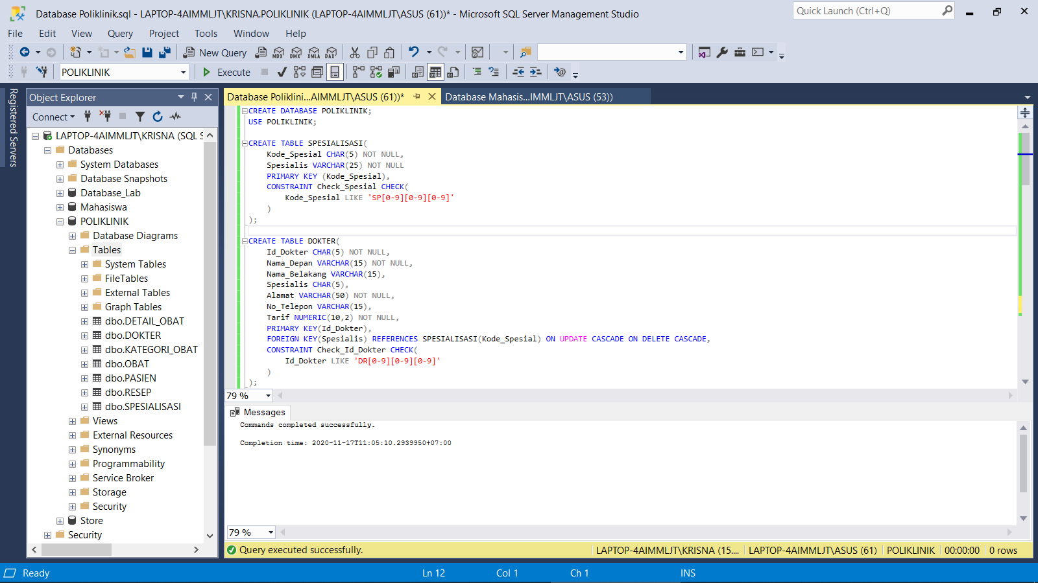

- Insert Tabel

INSERT INTO SPESIALISASI

VALUES ('SP001','Jantung'),

('SP006','Bedah'),

('SP005','Saraf'),

('SP007','Mata'),

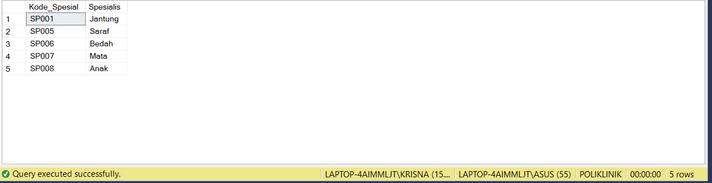 ('SP008','Anak');

INSERT INTO DOKTER

VALUES ('DR001','Syaiful','Anwar','SP001','Jakarta Pusat','+6281111222','150000'),

('DR003','Edi','Harto','SP006','Bogor','+6221211321','200000'),

('DR004','Andrea','Dian','SP008','Depok','+6288899988','100000'),

('DR011','Dewi','','SP006','Bekasi','+6212332111','120000'),

('DR009','Muhammad','Ridwan','SP001','Depok','+625656565','120000'),

('DR012','Agung','Pribadi','SP005','Jakarta Pusat','+624545111','180000'),

('DR007','James','Bon','SP007','Bekasi','+620000007','230000'),

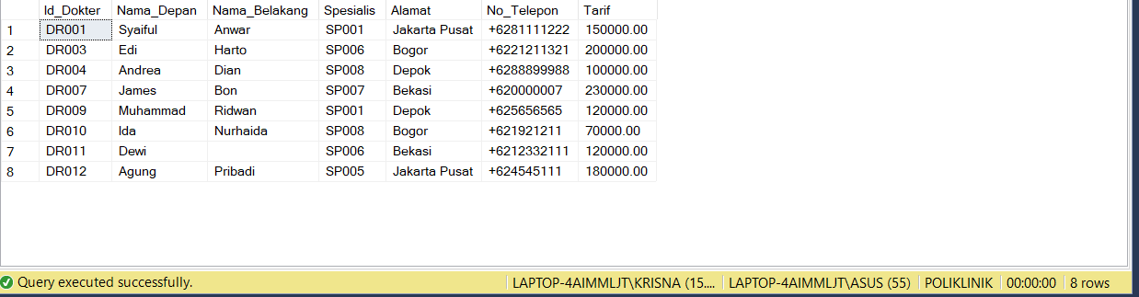 ('DR010','Ida','Nurhaida','SP008','Bogor','+621921211','70000');

INSERT INTO PASIEN

VALUES ('P0001','Ubet','','L','Bandung','+6282222123','21'),

('P0003','Juju','Jubaidah','P','Cimahi','','70'),

('P0002','Bon','Kurei','L','Bogor','','45'),

('P0005','Arya','Stak','P','Jakarta','+628989898','6'),

('P0008','Mario','Bolateli','L','Depok','+627117213','21'),

('P0009','Jamal','Widodo','L','Bekasi','+622167809','55'),

('P0010','Kiara','','P','Bogor','','4'),

('P0011','Bondan','Prakosa','L','Jakarta','+6200101011','21'),

('P0013','Gatot','Kaca','L','Solo','','45'),

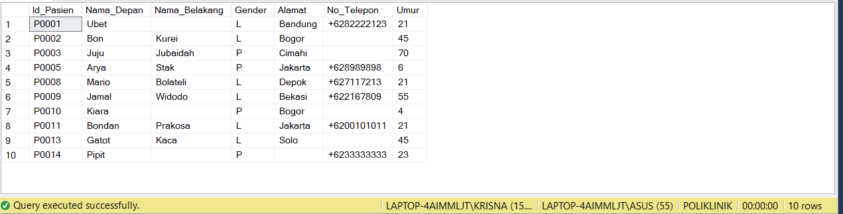 ('P0014','Pipit','','P','','+6233333333','23');

INSERT INTO RESEP

VALUES ('R250115001','P0001','DR011','2015/1/25',NULL),

('R250115002','P0009','DR001','2015/1/25',NULL),

('R260115001','P0008','DR007','2015/1/26',NULL),

('R270115001','P0014','DR003','2015/1/27',NULL),

('R300115001','P0010','DR010','2015/1/30',NULL),

('R300115002','P0013','DR003','2015/1/30',NULL),

('R010215001','P0009','DR001','2015/2/1',NULL),

('R010215002','P0003','DR009','2015/2/1',NULL),

('R010215003','P0010','DR010','2015/2/1',NULL),

('R020215001','P0005','DR004','2015/2/2',NULL),

('R020215002','P0009','DR001','2015/2/2',NULL),

('R020215003','P0014','DR012','2015/2/2',NULL),

('R030215001','P0005','DR004','2015/2/3',NULL),

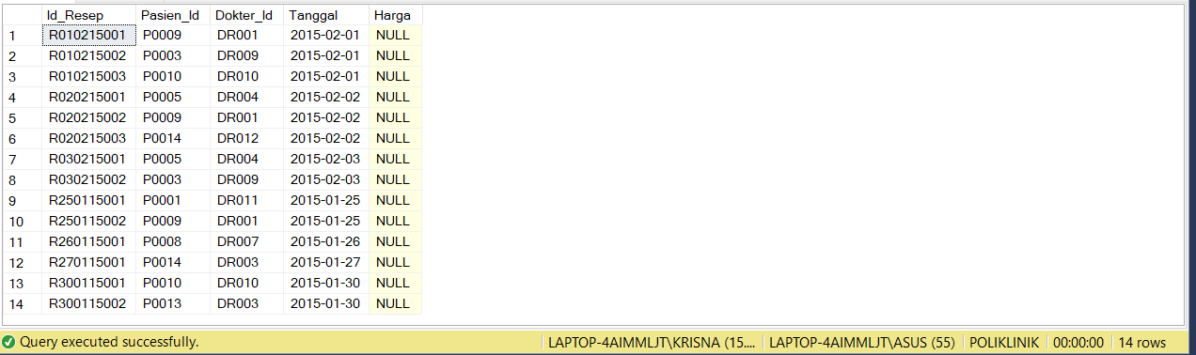 ('R030215002','P0003','DR009','2015/2/3',NULL);

INSERT INTO KATEGORI_OBAT

VALUES ('OK001','Jantung'),

('OK002','Saraf'),

('OK003','Infus'),

('OK004','Nutrisi'),

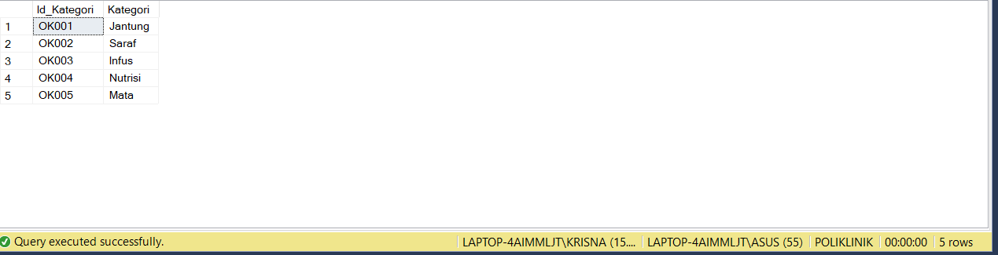 ('OK005','Mata');

INSERT INTO OBAT

VALUES ('OB001','Akrinor Tablet','65000','OK001'),

('OB002','Cardiject Vial','7800','OK001'),

('OB003','Fargoxin Injeksi','21000','OK001'),

('OB004','Kendaron Ampul','20000','OK001'),

('OB005','Tiaryt Tablet','16000','OK001'),

('OB006','Exelon Capsule 3 Mg','70000','OK002'),

('OB007','Fordesia Tablet','79000','OK002'),

('OB008','Reminyl Tablet 4 Mg','33000','OK002'),

('OB009','Albucid Tetes Mata','15000','OK005'),

('OB010','Cendo Fenicol Salep Mata','20000','OK005'),

('OB011','Interflox Tetes Mata','36000','OK005'),

('OB012','Haemaccel Infus','200000','OK003'),

('OB013','Human Albumin Infus','900000','OK003'),

('OB014','Curfos Syrup','74000','OK004'),

('OB015','Vitacur Syrup','36000','OK004'),

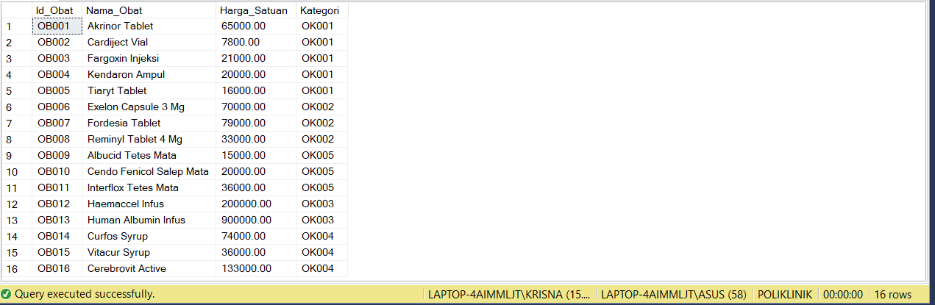 ('OB016','Cerebrovit Active','133000','OK004');

INSERT INTO DETAIL_OBAT

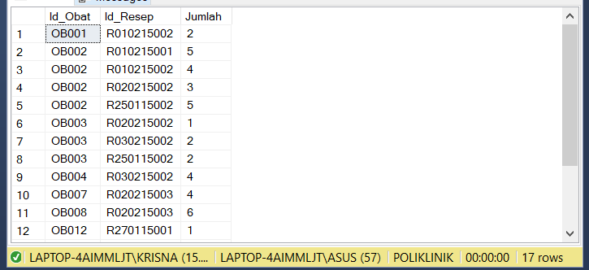VALUES ('OB013','R250115001','1'),

('OB002','R250115002','5'),

('OB003','R250115002','2'),

('OB012','R270115001','1'),

('OB015','R300115001','1'),

('OB002','R010215001','5'),

('OB001','R010215002','2'),

('OB002','R010215002','4'),

('OB014','R010215003','1'),

('OB016','R020215001','2'),

('OB002','R020215002','3'),

('OB003','R020215002','1'),

('OB007','R020215003','4'),

('OB008','R020215003','6'),

('OB016','R030215001','1'),

('OB003','R030215002','2'),

('OB004','R030215002','4');

II Soal & Jawaban

1. Buatlah query untuk mengembalikan data obat yang harga satuannya tidak lebih dari Rp 50.000,00. Tampilkan nama obat, harga, dan nama kategorinya.

SELECT Nama_Obat,

Harga_Satuan,

KATEGORI_OBAT.Kategori

FROM OBAT,KATEGORI_OBAT

WHERE OBAT.Kategori = KATEGORI_OBAT.Id_Kategori AND

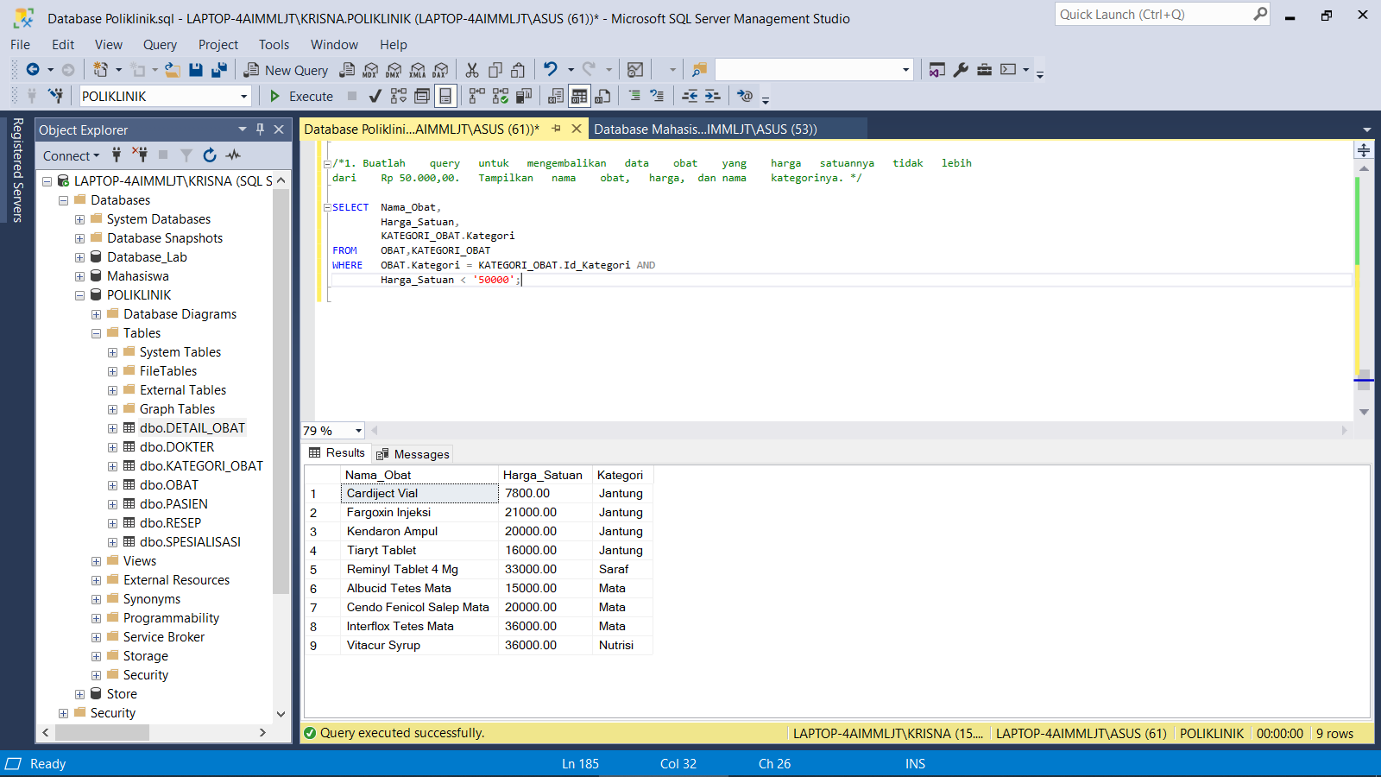 Harga_Satuan < '50000';

2. Buatlah query untuk mengembalikan data pasien yang nama depannya mengandung huruf ‘o’. Tampilkan semua kolomnya kecuali nomor telepon.

SELECT Id_Pasien,

CONCAT(Nama_Depan,' ',Nama_Belakang) AS 'Nama_Pasien',

Gender,

Alamat,

Umur

FROM PASIEN

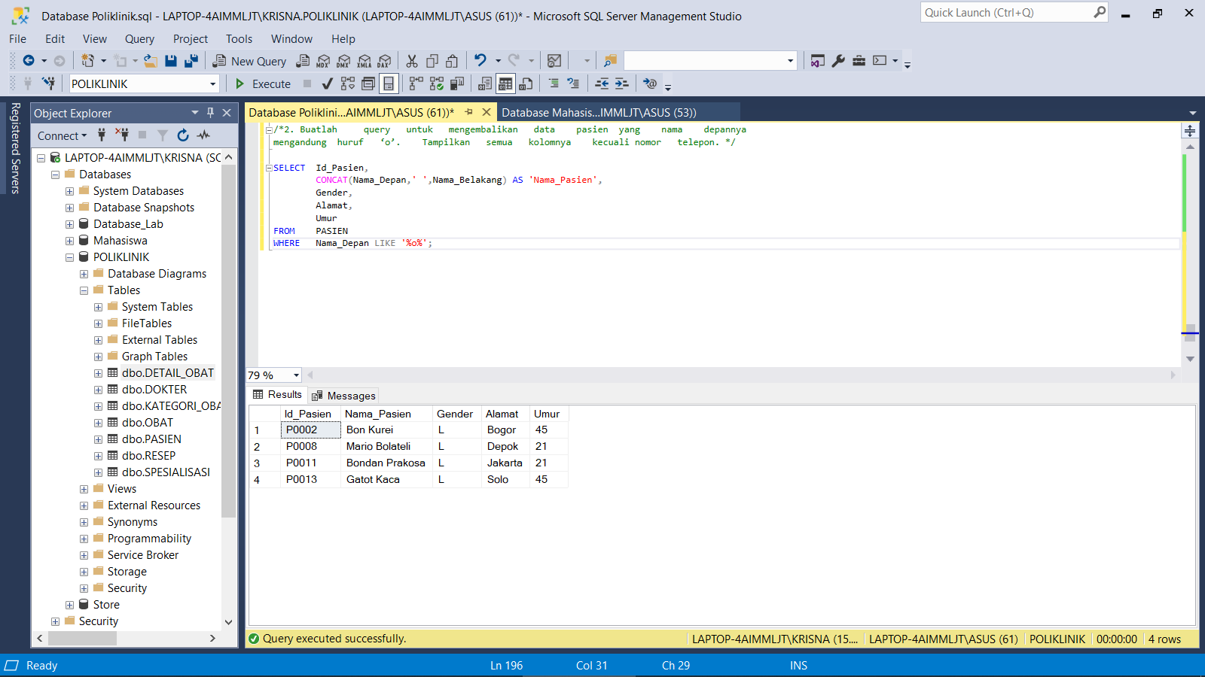WHERE Nama_Depan LIKE '%o%';

3. Buatlah query untuk mengembalikan data pasien yang berobat pada dokter spesialis jantung. Tampilkan data nama (nama lengkap), umur, dan nama dokter yang menangani.

SELECT DISTINCT CONCAT(Pasien.Nama_Depan,' ',Pasien.Nama_Belakang) AS 'Nama_Pasien',

Umur,

CONCAT(Dokter.Nama_Depan,' ',Dokter.Nama_Belakang) AS 'Dokter'

FROM PASIEN, RESEP, DOKTER, SPESIALISASI

WHERE PASIEN.Id_Pasien = RESEP.Pasien_Id AND

DOKTER.Id_Dokter = RESEP.Dokter_Id AND

DOKTER.Spesialis = SPESIALISASI.Kode_Spesial AND

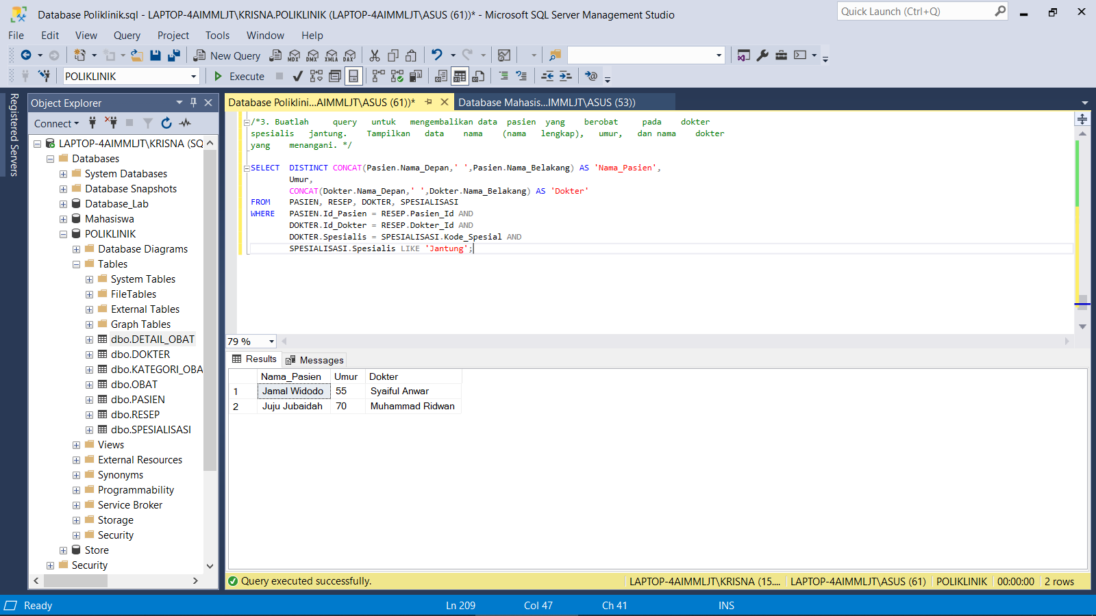 SPESIALISASI.Spesialis LIKE 'Jantung';

4. Buatlah query untuk menampilkan resep untuk obat ‘Cardiject Vial’. Tampilkan nomor resep, dan tanggalnya.

SELECT RESEP.Id_Resep,

Tanggal

FROM RESEP, DETAIL_OBAT, OBAT

WHERE RESEP.Id_Resep = DETAIL_OBAT.Id_Resep AND

DETAIL_OBAT.Id_Obat = OBAT.Id_Obat AND

Nama_Obat LIKE 'Cardiject Vial'

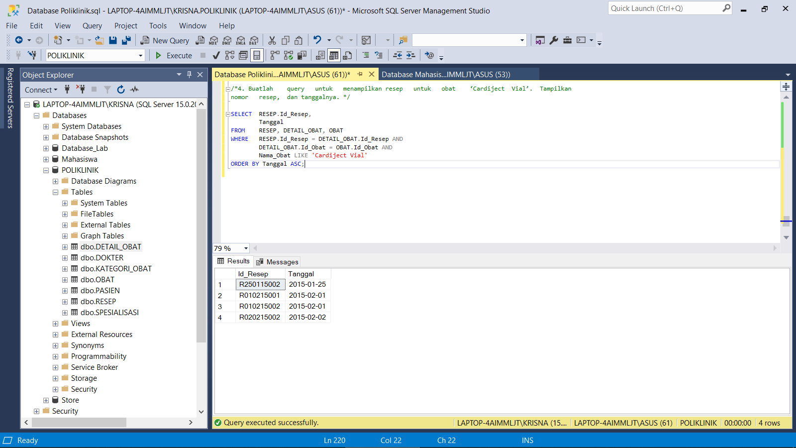ORDER BY Tanggal ASC;

5. Buatlah query untuk mengembalikan daftar nama obat yang dalam satu resep diminta dalam jumlah lebih dari 2. Tampilkan id obat dan nama obatnya tanpa duplikasi.

SELECT DISTINCT OBAT.Id_Obat AS Id_Obat,

Nama_Obat

FROM OBAT, DETAIL_OBAT, RESEP

WHERE OBAT.Id_Obat = DETAIL_OBAT.Id_Obat AND

DETAIL_OBAT.Id_Resep = RESEP.Id_Resep AND

Jumlah > 2;

